Unsolved Murders of Glinda Pulley and Tyler Jones - Warrenton, NC 2005
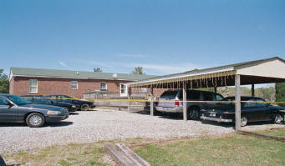
Above: Location where crime occurred
Inside Crime Scene 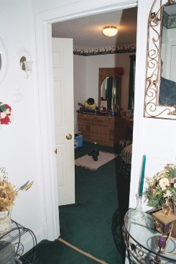
Crime Scene Analysis by Dr. Godwin

January 12, 2011
Warren County Sheriff's Office
132 Rafters Lane
PO Box 678
Warrenton, NC 27589
RE: Glinda Pulley and Tyler Jones Death Investigation
I am writing this letter as a follow-up to our meeting at the Warren County Sheriff’s Office on January 4, 2011. The purpose of our January 4th meeting was two-fold: 1) to bring your attention to two specific items from the crime scene, which should be tested by the SBI crime lab; and 2) to have a general discussion about the deaths of Glinda Pulley and Tyler Jones.
During our meeting two evidentiary items were reviewed for the purpose of forensic testing by the SBI crime lab. The first evidentiary item reviewed was the alleged suicide note. Although the note had previously been examined for prints, I made you aware of a dark spot located in the upper left side of the paper, which has never been tested. I indicated to you that I was not sure if this dark spot was blood but that it should be forensically tested to determine if it is blood. You agreed to have the letter sent off to the SBI crime lab.
The second evidentiary item reviewed during our meeting for the purpose of forensic testing was a green and white striped pillow found lying at the foot of Glinda Pulley’s bed. The pillow originally came from Tyler’s bed as the pillow case pattern matched his bed sheets. The pillow had been shot through once. The pillow had a shotgun entrance near the center of the pillow and an exist hole located at the top end of the pillow. I examined photos of the pillow numerous times under magnification and discovered a small red stain near the entrance area. The red stain gives the appearance of a blood spatter. You agreed to have the pillow case sent off to the SBI crime lab and the red stain forensically examined.
To my knowledge no one was aware of either the dark spot on the note or the red stain on the pillow until I brought it to your attention during our meeting.
Forensic DNA testing of the dark spot on the note and red stain on the pillow could result in one or two of the following findings:
1. Dark spot/Stain is negative for blood (should be presumptive and confirmatory tests)
2. Dark spot/Stain is positive for blood
3. DNA of dark spot/stain matches Glinda Pulley’s DNA
4. DNA of dark spot/stain matches Tyler Jones’ DNA
5. DNA of dark spot/stain is an unknown person’s DNA or suspect's DNA
In order to carry out the forensic testing you will need the DNA profiles from both Glinda and Tyler. Do you have that information?
A general discussion about the deaths of Glinda Pulley and Tyler Jones resulted in an important fact not being previously investigated. Tyler’s closest friend and cousin, Michael Pulley, Jr. (Bean) who was 12 at the time of the murders, was never interviewed. The failure to interview Michael Pulley, Jr. can only be laid at the feet of the Warren County Sheriff Department and the North Carolina SBI. It is my understanding that Michael, Jr. was devastated by the death of Tyler. He has only recently begun to talk about the events surrounding the day Glinda and Tyler were found. Based on a conversation with Michael, Jr., now 17, has revealed for the first time that he witnessed Dennis Carter coming out of Glinda’s house at an earlier time than when Dennis was seen walking out with Danny Jones, Jr. I think it is imperative to any criminal investigation, no matter how many years later, that all witnesses should be thoroughly interviewed.
Another witness who should be interview is Daniel Jones’ finance. Her name is ______. She was at the Pulley home on the morning the bodies were discovered. The suspect made the following statement to her: “Tyler shot his mom” before any police arrived. I would think that this type of information might be useful; she should be interviewed.
During our conversation the topic of Toluene was brought up. I find it highly suspicious that a rag with the chemical/solvent Toluene on it was found near Tyler’s body. While there may not be a clear indication that Toluene was used to subdue Tyler the substance may have been used to wipe down the 410 shotgun; no fingerprints were found on the shotgun. However, I am not aware of any forensic examination of the gun to determine if residue from Toluene or any other substance was present. In my opinion the gun should now be forensically tested for any residue to determine if Toluene was used to wipe down the gun.
A review of the crime scene photographs indicates that a struggle occurred beside Glinda’s bed. Several items were found in disarray, which tend to support this theory. For example, the telephone was knocked off the bedside table and was lying off the hook in an upside down position. Glinda’s ring was found near the phone, on the floor, wedged between the carpet and the wall molding. This finding likely indicates some force was used to propel the ring into that position (see photo below).
When there are signs of a struggle at a crime scene it is advisable to preserve the victim’s hands by bagging them and then have their nails examined for any possible trace evidence. To my knowledge Tyler’s fingernails were not preserved or clipped by the medical examiner for forensic testing. If Tyler’s fingernails were collected and remain a part of the evidence, then they need to be submitted for forensic examination.
It is also important to point out that based on the medical examiner’s request no toxicology was performed on Tyler’s liver, gastric contents or urine. This was confirmed by Dr. Ruth E. Winecker, Chief Toxicologist at UNC Chapel Hill. Below is Dr. Winecker’s e-mail to me dated January 11, 2011:
We conduct testing on the most appropriate specimens based upon the circumstances of the death and the questions posed to the laboratory by the pathologist. The general answer to your question is that testing of the liver,gastric contents and urine were not required to add useful information in assigning the cause and manner of death in this case.
Ruth E. Winecker, Ph.D., D-ABFT
Chief Toxicologist
The failure to run toxicology tests on the liver, gastric contents and urine was a major mistake and only reinforces my opinion that the ME who performed Tyler’s autopsy, Dr. Maryanne Gaffney-Kraft had a bias towards the suicide theory.
Do you know if the gastric contents and samples from the liver and urine are available for testing?
A more detailed report from me is forthcoming about the deaths of Glinda Pulley and Tyler Jones.
Sincerely,

Dr. Maurice Godwin
Godwin Trial & Forensic Consultancy, Inc.

One aspect of my crime scene analysis and reconstruction found that the crime scene was staged and a struggle occurred (see photos below):
Locations of two 410 Shotgun Shells - Entrance of Master Bath
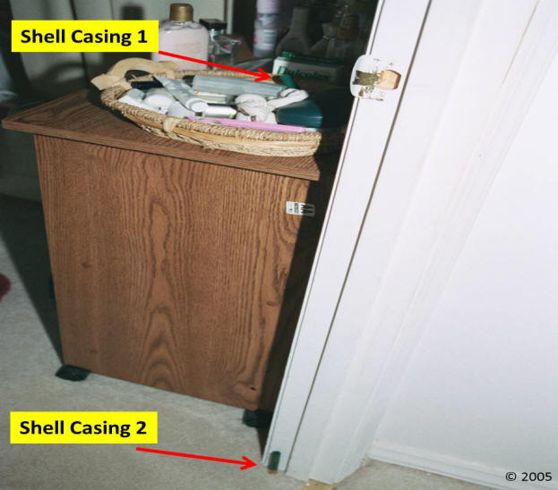
Notice how shell casing 1 is placed in the basket inside of the bathroom - around the corner of the door.
Notice how perfectly shell casing 2 is sitting up on the carpet.
The shell casings have been staged. The location of the bathroom door is about 6 feet from where the gun was located; the gun did not eject the shells.

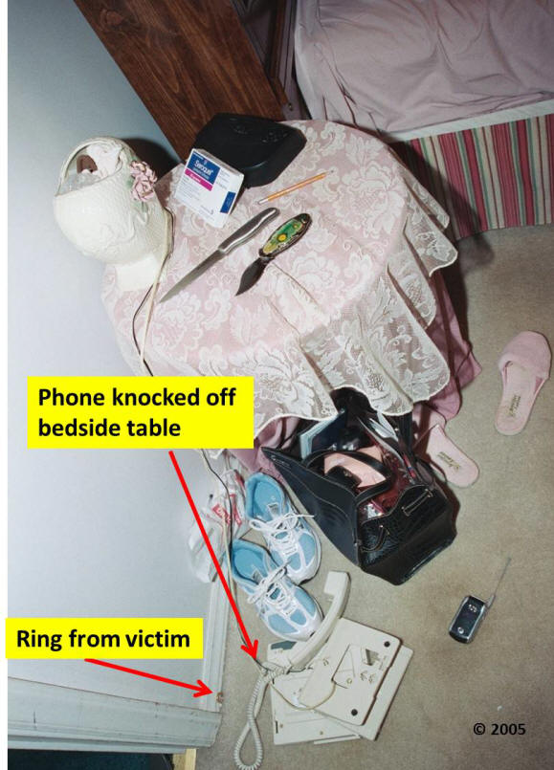
A review of the crime scene photographs indicates that a struggle occurred beside Glinda’s bed. Several items were found in disarray, which tend to support this theory. For example, the telephone was knocked off the bedside table and was lying off the hook in an upside-down position. Glinda’s ring was found near the phone, on the floor, wedged between the carpet and the wall molding. This finding likely indicates some force was used to propel the ring into that position (see photo above). Just to note, the knives on the bedside table were used to gain entry into the bedroom due to the door being locked.

